**LAB ASSAIGNMENT 2**

NAME :**GURRAM VENKATA TARUN KUMAR**

ROLL NO : **EE20B012**

1. **Conversion of 4 digit decimal Ascii code to binary coded numbers(BCD)**

* Verilog code

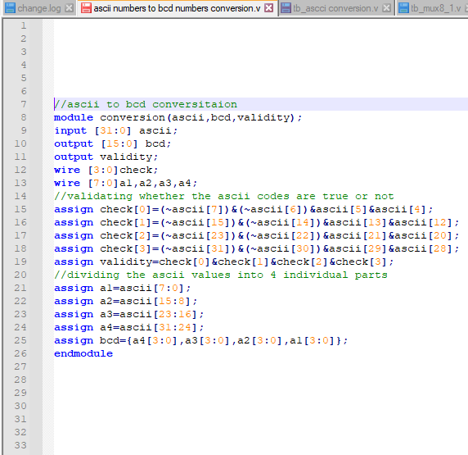

Here I have divide given 32 bit asciii code into 4 parts and I extracted the required thing to convert from the ascii code to bcd format

And It requires 16 bits to represent them

I have written the validity variable also the check whether the given ascii values given the number charactes or not

* Test bench code

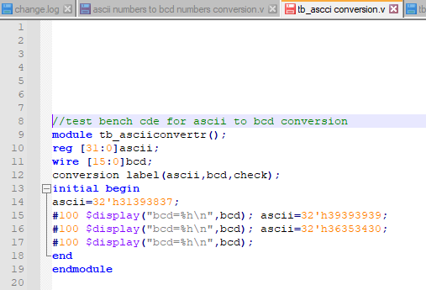

Here I used an extra display inbuilt function to get the printed output as below

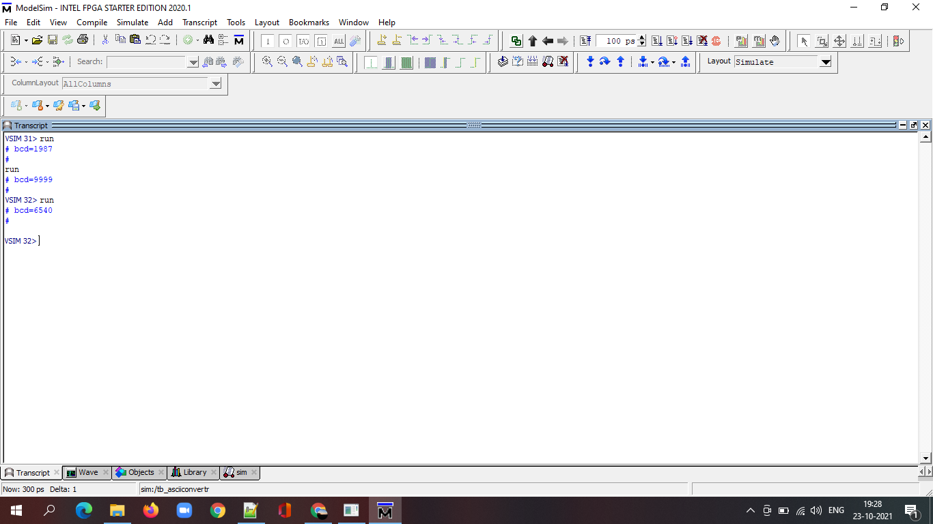

* Wave form

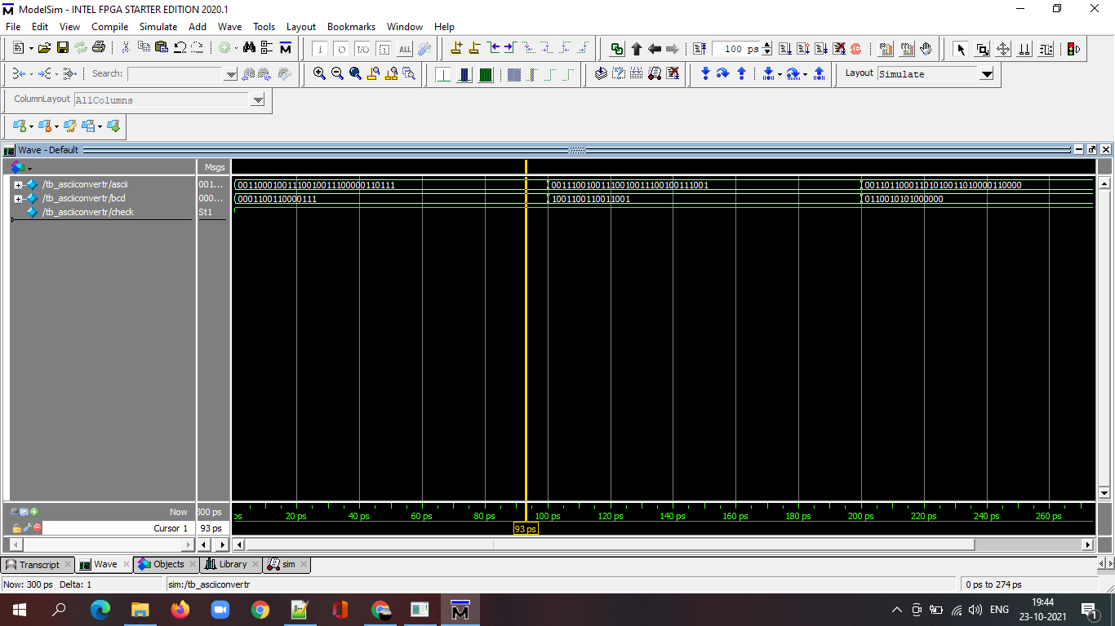

1. **Conversion of 4 digit decimal binary coded numbers(BCD) Ascii code**

* Verilog code

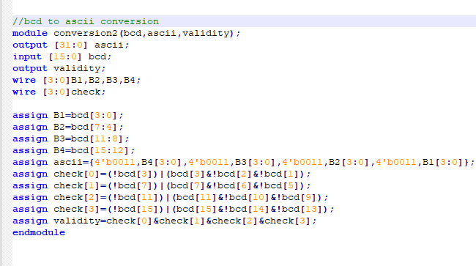

Here I have divide given 16 bit BCD into 4 parts and I attached the required thing to convert from the BCD to ascii format

And Ascii requires 32 bits to represent them

I have written the validity variable also the check whether the given BCD values are valid or not as they are in binary format which values from 0-9 only

* Test bench code

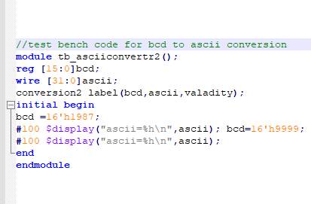

Here I used an extra display inbuilt function to get the printed output as below

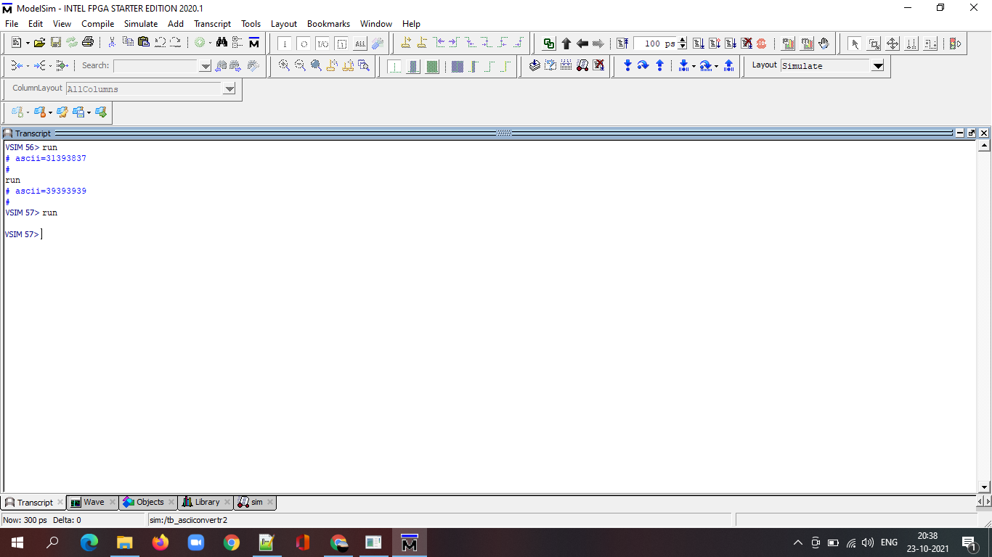

* Wave form

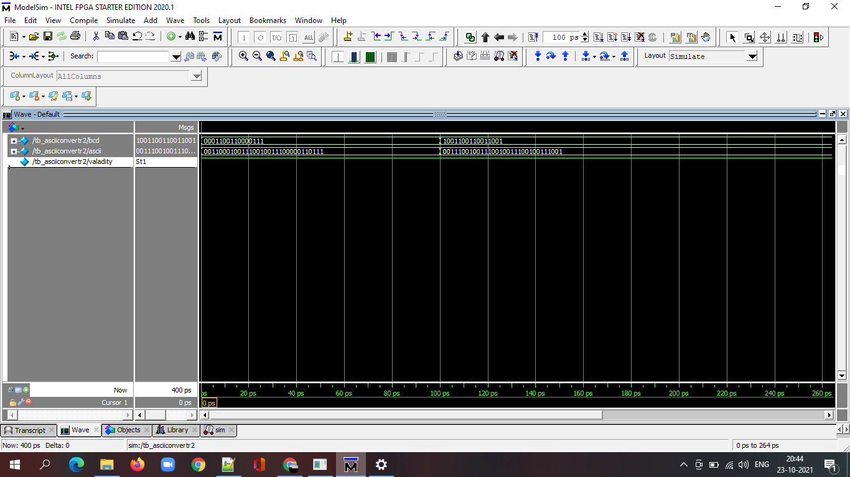

**Observations:**

The main logic behind this code is

The hexa -decimal representation form of ascii values are as follow

30-0,31-1,32-2,33-3,34-4,35-5,36-6,37-7,38-8,39-9,

So it is we can find the easiest relationship between asciii values and bcd codes

**Learnings:**

How to convert ascii to bcd and vice versaa